 Good Hygiene Practices - Reducing the Spread of Infections due to Bacteria and Viruses

Winter season comes in, the diseases like cold, asthma, sore throat, Acute Gastroenteritis, painful joints, cold sores, cold hands (Raynaud’s phenomenon), dry skin and Flu are most common in this season, and majority of diseases (such as the flu, colds, or strep throat) are Contagious spread from person to person in several ways, so prevention through hygienic habits is more important in this season.

Prevention is better than a cure because it literally prevents the discomfort and costs of becoming sick or experiencing a similar preventable event.

It also often takes less effort to prevent something than to cure it, hence the popular expression "an ounce of prevention is worth a pound of cure."

Using common prevention strategies such as regular hand washing helps prevent illnesses like colds and flu from spreading. Taking the time to prepare and store food safely prevents food poisoning. In both cases, it is much more efficient and cost-effective to prevent the illness than to cure it.

Hands are the most common way in which micro-organisms, particularly bacteria, might be transported and subsequently cause infections, especially in those who are most susceptible to infection.

Good hand hygiene is the most important practice in reducing transmission of infectious agents.
As intact skin is a natural defense against infection, cuts and abrasions reduce the effectiveness
Of hand hygiene practices. Breaks or lesions of the skin are possible sources of entry for infectious
Agents and may also be a source of them. Similarly, the presence of fingernail disease may reduce the efficacy of hand hygiene and result in the transmission of pathogens.

What can I do to reduce the spread of "germs"?
The most important way to reduce the spread of infections is hand washing this applies to everyone - always wash regularly with soap and water. Also important is to get a vaccine for those infections and viruses that have one, when available.
    - To reduce the risk of cross-transmission of infectious agents, cuts and abrasions should be covered with waterproof dressings.
    - Generally better to use alcohol-based hand rub as it is effective and easy to use but, if hands are visibly dirty, they need to use soap and water first
    - Performing hand hygiene regularly reduces the risk of infection to you and other.
    - After hand hygiene, the hands should be dry. If alcohol-based hand rub is used, the solution will dry on the hands, or hand should be patted dry after hand washed with soap and water.
    - Appropriate use of hand lotion or moisturizers added to hand hygiene preparations is an important factor in maintaining skin integrity, encouraging adherence to hand hygiene practices and assuring the health and safety of the hands.

Hand hygiene (hand washing) procedures
Hand hygiene should be performed for between 15 seconds and 3 minutes depending on the level of hand hygiene being performed. Washing for longer than these times is not recommended as this may damage the skin but,
- Ensure the sink area is free from extraneous items, e.g. medicine cups, utensils
- Ensure jackets/coats are removed, and wrists and forearms are exposed
- Jewellery must be removed Ensure nails are short (false nails must not be worn)

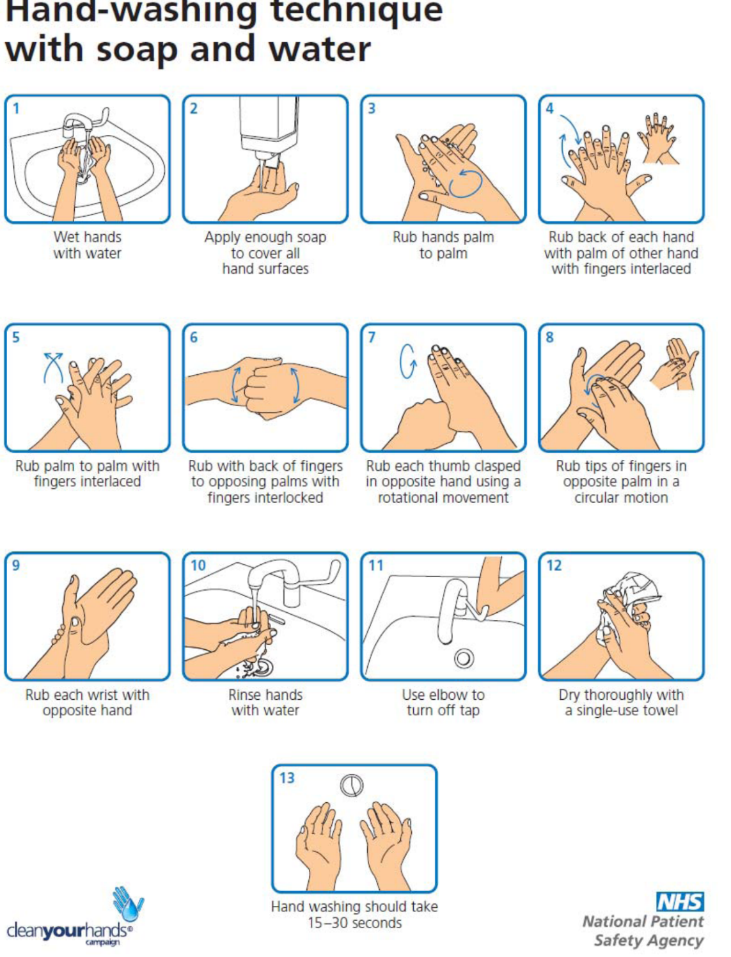

Here other methods as mentioned below beyond hand washing that can also help to slow or stop the spread of infections.
What are good practices to slow the spread of infections?
Ways you can reduce or slow the spread of infections include:
- Get the appropriate vaccine.
- Wash your hands frequently.
- Stay home if you are sick (so you do not spread the illness to other people).
- Use a tissue, or cough and sneeze into your arm, not your hand. Turn away from other people.
- Use single-use tissues. Dispose of the tissue immediately.
- Wash your hands after coughing, sneezing or using tissues.
- If working with children, have them play with hard surface toys that can be easily cleaned.
- Do not touch your eyes, nose or mouth (viruses can transfer from your hands and into the body).
- Do not share cups, glasses, dishes or cutlery.
What can a workplace do?
Workplaces can help by:
- Having an infection control plan.
- Providing clean hand washing facilities.
- Offering waterless alcohol-based hand sanitizers.
- Providing boxes of tissues and encourage their use.
- Reminding staff to not share cups, glasses, dishes and cutlery. Be sure dishes are washed in soap and water after use.
- Removing magazines and papers from waiting areas or common rooms (such as tea rooms and kitchens).
- Considering cleaning a person's workstation or other areas where they have been if a person has suspected or identified influenza.
- Making sure ventilation systems are working properly.
In the event of an Endemic or Epidemic flu, wearing masks when face-to-face, while travelling, while coughing it helpful to prevent the infection or virus has entered the community. Special handling of linen or waste contaminated with secretions from persons thought to be or who are sick is required.
If cleaning is necessary, how should it be done?
Additional measures may be required to minimize the virus from transmitting by hard surfaces (sinks, door and cupboard handles, railings, objects, counters, desk etc.). The length of time a virus survives on hard surfaces depends on the type of virus. Most studies have shown that the flu virus can live and potentially infect a person for only 2 to 8 hours after being deposited on a surface." Other estimates range up to 24 and 48 hours.
In most workplaces and homes, cleaning floors, walls, doorknobs, etc. with regular disinfectants or soap and water is very adequate. In some workplaces, such as a hospital or health care facility, specific cleaning and disinfection steps are often required.

What is meant by social distancing?
Social distancing is a strategy where you try to avoid crowded places, large gatherings of people or close contact with a group of people. In Epidemic or Pandemic situations, viruses can easily spread from person to person. In general, a distance of one meter (3 feet) will slow the spread of a disease, but more distance is more effective.
Social distancing should be recommended in endemic or pandemic areas, steps to follow include:
- Use telephone, video conferencing, or the internet to conduct as much business as possible (including within the same building).
- Allow employees to work from home, or to work flexible hours to avoid crowding the workplace.
- Cancel or postpone any travel, meetings, workshops, etc. that are not absolutely necessary.
- Drive, walk, or cycle to work, but try to avoid public transit. Alternatively, workplaces can consider allowing staff to arrive early/late so they can use public transit when it is less crowded.
- Allow staff to eat at their desks or have staggered lunch hours to avoid crowded lunch rooms.
- Spend as little time as possible in tea rooms or photocopy centers.
- When meetings are necessary, have the meeting in a larger room where people can sit with more space between them (at least about one meter apart). Avoid shaking hands or hugging.
- Encourage staff to avoid social gatherings outside of work where they might come into contact with infectious people.
What should a workplace do if an employee becomes ill at work?
Reasons to determine "fitness to work" may depend on a number of issues such as size or type of organization, job responsibilities of employees, ease of working from home (via internet connections, etc.).
Generally, employees should be allowed and encouraged to stay at home if they are not feeling well. However, in the event of a pandemic, use screening tools or a list of symptoms as a checklist. If employees are showing any signs, allow them to go or remain at home. If there is doubt if a person is sick, they should stay home until they feel well and are able resume their regular activities.
Good management and organizational processes are crucial to make sure that high standards of infection prevention and control are developed and maintained.
Good infection prevention and control are essential to ensure that people who use health and social care services receive safe and effective care. Effective prevention and control of infection must be part of everyday practice and be applied consistently by everyone.



